DLNA Digital Media Renderer

Low Level Design

AllGo Embedded Systems Pvt Ltd
© Copyright 2019
Version History
Version Number | Date | Author(s) | Remarks
0.1 | 7th June 2019 | Ashish P S | Initial version
0.2 | 14th June 2019 | Ashish P S | Updated review comments changes
0.3 | 18th June 2019 | Ashish P S | Updated review comments changes
1.0 | 18th June 2019 | Ashish P S | Baselined version

Table of Contents
1 Introduction 3
1.1Overview 3
1.2Purpose 3
1.3Definitions and Acronyms 3
2 References 4
3 Low Level Architecture 4
3.1Sub-modules 4
3.1.1UPnP Device 5
3.1.2XML Parser 8
3.1.3Web Server 8
3.1.4Rendering Control Service 8
3.1.5ConnectionManager Service 9
3.1.6Audio-Video Transport Service 9
3.2Performance Design 9
3.3Functional Design 9
4 Class/SubModule Design 10
4.1Class Design 11
4.1.1Sequence Diagram 12
5 FileStructure 18
6 Interfaces 19
7 Limitation 19
8 Assumption 19
9 Traceability 19
10 Platform Dependencies 21
11 External References 22
11.1List of reference readings links: 22
11.2 “Design Patterns Explained” by Alan Shalloway and James R. Trott 22

Introduction

Overview
This document describes the low level design of the DLNA (Digital Living Network Alliance) DMR (Digital Media Renderer) module for RICM (Rear Infotainment Control Module). It describes the underlying design of the module, the state diagram interaction and the design flow diagram.

Purpose
The purpose of this document is to provide a detailed description of the low level design for DLNA DMR module.

Definitions and Acronyms

S.No. | Terms | Definitions
1 | DLNA | Digital Living Network Alliance
2 | DMR | Digital Media Renderer
3 | SCPD | Service Control Protocol Document
4 | UDN | Unique Device Name
5 | DCP | Device Control Protocol
6 | UPnP | Universal Plug and Play
7 | AVT | Audio Video Transport
8 | RCS | Rendering Control Service
9 | URI | Universal Resource Identifier
10 | SCPD | Service Control Point Definition
11 | SOAP | Simple Object Access Protocol
12 | RICM | Rear Infotainment Control Module
13 | TCP | Transmission Control Protocol
14 | IP | Internet Protocol
15 | HTTP | Hyper Text Transfer Protocol

References
References mentioned below are part of DLNA DMR:
Example
- DLNA_DMR_Requirement.docx
- Digital_Media_Rendered_HLD.doc
- cpp_coding_guidelines_final.pdf

Low Level Architecture
Proposed design for DLNA DMR will have following modules:
- DMR C++ library
- JNI interface layer
- Sample Java application

The DMR C++ library implementation interfaces with the UPnP library to achieve device discovery and control. This module will be responsible for the following :
- Make DMR visible over network as a potential digital media renderer.
- Advertise services offered by DMR.
- Handle control point subscriptions.
- Handle control point actions and queries.
- Send last changed state variable status to control points.
- Interface with android sample Java application which will perform the media rendering.

The JNI interface layer is to bridge C++ library functionality with sample Java application. This module
will mostly perform data conversion between Java layer and C++ layer. This module will not have logical components.

The sample Java application will perform the actual rendering of media content. It is left to application implementation on how this component will achieve media rendering. It is assumed that the application will support HTTP streaming capability. All the media command(play, pause, stop.. etc) will be directed to this application by DMR.

Sub-modules
DLNA DMR C++ library will consist of following sub-modules:
- UPnP device
- XML parser
- Web Server
- Rendering control service
- ConnectionManager service
- Audio-Video transport (AVT) service

UPnP Device
The UPnP device component encloses data as per UPnP device architecture. It contains vendor-specific information like URLs for subscription and duration of subscriptions or specific variable values, service identifiers or variable names, etc. Data Enclosed by device component are as follows:

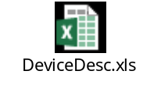

XML Parser
The xml parser component will be responsible for parsing the services description files. The service files contain information related to actions offered by the service and the valid values supported by each of the actions. These services information will be maintained throughout the service runtime and will be made available to the interested control points when queried.

Web Server
The Web-server component provides communication between the DMR and control points. It makes use of virtual directory concept. As per this concept, DMR registers all service description XML files with the webserver. Therefore, all webserver requests containing the given file path are read and response is written using functions passed in a UpnpVirtualDirCallbacks structure registered via UpnpSetVirtualDirCallbacks .

Rendering Control Service
The Rendering Control Service provides a set of actions that allow the Control Point to control how the DMR renders a piece of incoming content. This includes rendering actions such as Brightness, Contrast, Volume, Mute, etc. This component will check whether the action is allowed and respond with appropriate response.
Follwing file contains the state variables, state variable allowed values, actions and action arguments supported by Rendering Control Service:

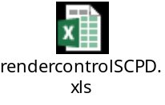

ConnectionManager Service
Connection manager service provides the control points with protocol info. This allows a Control Point to enumerate the transfer protocols and data formats that are supported by the DMR.
Follwing file contains the state variables, state variable allowed values, actions and action arguments supported by ConnectionManager Service:

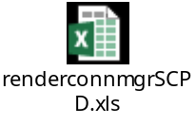

Audio-Video Transport Service
AV Transport Service provides actions to control the flow of the media content. This includes the ability to Play, Stop, Pause, Seek, etc. This component will check the current state of AV transport state machine and depending on the current state it will either propagate the request to sample Java application or respond with appropriate error response.
Follwing file contains the state variables, state variable allowed values, actions and action arguments supported by Audio-Video Transport Service:

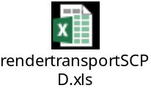

Performance Design
The DMR design makes use of threads for parallel processing. The event handler thread handles commands from control points and the command execution thread handles the actual API requests from sample Java application. This aids in eliminating the limitation of blocking the calling thread.

Functional Design
The core implementation of DMR will consist of threads for parallel processing.
Following threads will be running in parallel performing respective functionalities:
- Event handler thread
- Playback thread

The event handler thread handles all the control point commands/subscription requests/get state variables requests from control points. All these requests are expected to be processed within a specified timeout (10 seconds. NOTE: this value could be reduced or set to desired value by configuration parameter “DefaultCallbackTimeout”). If request processing takes more time than the specified timeout, then appropriate response will be sent by DMR.

UPnP Av Transport protocol mandates that any change in the required state variables should be evented to subscribed control points. Therefore, relative track playback time should also be updated to the control points, for this playback thread will unblock once playback starts successfully. Playback thread will query sample Java application every 500ms to get the elapsed time of track and update the same to control points.

Appropriate locks will be used to protect the atomic data and avoid unauthorized modification of data by internal modules. No threads are used for API execution as there are no time-consuming/CPU intensive operations done as part of API execution. This makes all API execution in application context.

Class/SubModule Design
Following classes will form the entire DMR:
- UPnPDeviceDescriptor
- UPnPServiceDescriptor
- Service
- AVTransport
- Rendering Control

The UpnPDeviceDescriptor class maintains information parsed from the device description XML. The data can be classified as vendor specific information like device type, device name,
UDN, UPC, URL base, manufacturer model, service related information like serviceType, serviceId, SCPDURL, controlURL, eventSubURL. The information enclosed in device description XML file are static data and unlikely to change during process runtime. Apart from these, UpnPDeviceDescriptor class also encapsulates services offered of DMR.

UPnPServiceDescriptor class provides common template for all the services. Services offered by DMR will implement UpnPServiceDescriptor class overiding methods and providing implementations specific to the individual service. This class provides actions, arguments and state variables list which will be populated by individual services.

The Service class is a composition of UPnPDeviceDescriptor and UPnPServiceDescriptor classes objects. It contains the player and device callbacks registered by application and provides interfaces to expose service and device descriptions to application.

The AV Transport class provides transport functionality. It provides interfaces to set current and next AV Transport URI, to get transport capabilities, current playing track metadata info, get current track position info, get current play mode, get current play status, play current track, pause current track playback, seek playback to desired position, stop current track playback, go to next song.

Av Transport supports following transport states:
- E_DMR_PLAY_STATUS_PLAYING – playback is in progress
- E_DMR_PLAY_STATUS_STOPPED – Playback is stopped
- E_DMR_PLAY_STATUS_PAUSED – playback is paused
- E_DMR_PLAY_STATUS_TRANSITION – When DMR is processing any of the supported commands
Following table shows the playback related commands and in which states these will be allowed. Any state transition request made by control point for unallowed states will be rejected by DMR and errorCode 701(transition not allowed) will be sent to control point.

Command | Allowed States
SetAvTransportURI | E_DMR_PLAY_STATUS_STOPPED
SetNextAvTransportURI | E_DMR_PLAY_STATUS_STOPPED  E_DMR_PLAY_STATUS_PLAYING  E_DMR_PLAY_STATUS_PAUSED
Play | E_DMR_PLAY_STATUS_STOPPED  E_DMR_PLAY_STATUS_PLAYING  E_DMR_PLAY_STATUS_PAUSED
Pause | E_DMR_PLAY_STATUS_PLAYING
Stop | E_DMR_PLAY_STATUS_PLAYING  E_DMR_PLAY_STATUS_PAUSED
Seek | E_DMR_PLAY_STATUS_PLAYING  E_DMR_PLAY_STATUS_STOPPED
Next | E_DMR_PLAY_STATUS_PLAYING  E_DMR_PLAY_STATUS_STOPPED

The Rendering Control class provides fuctionality to control brightness, contrast, volume, mute.

Class Design

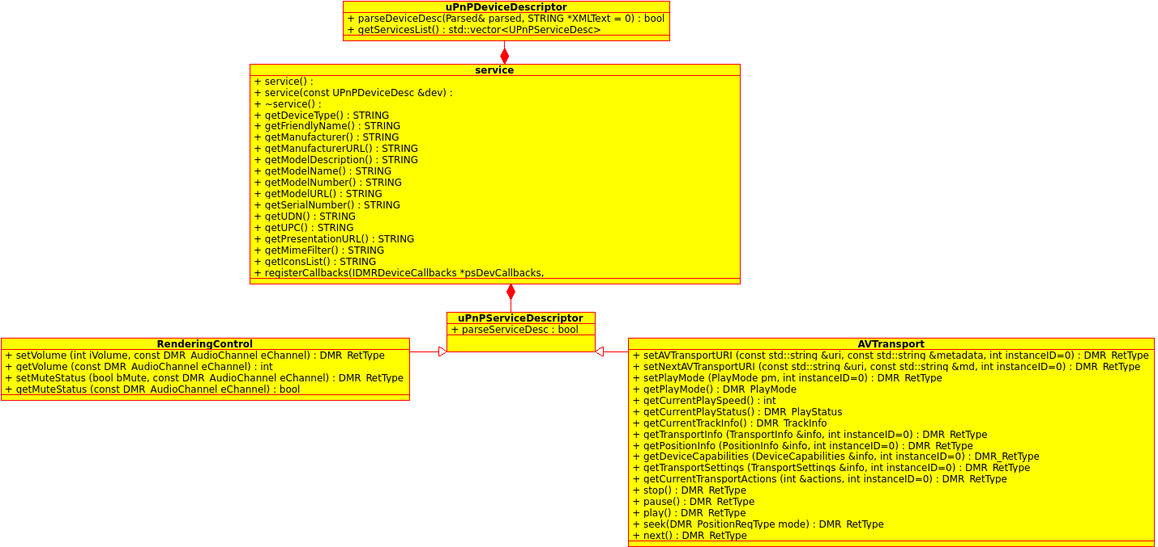

Fig. 2.1 DLNA DMR class diagram.

Sequence Diagram
- Below figure shows DMR internal thread interactions.
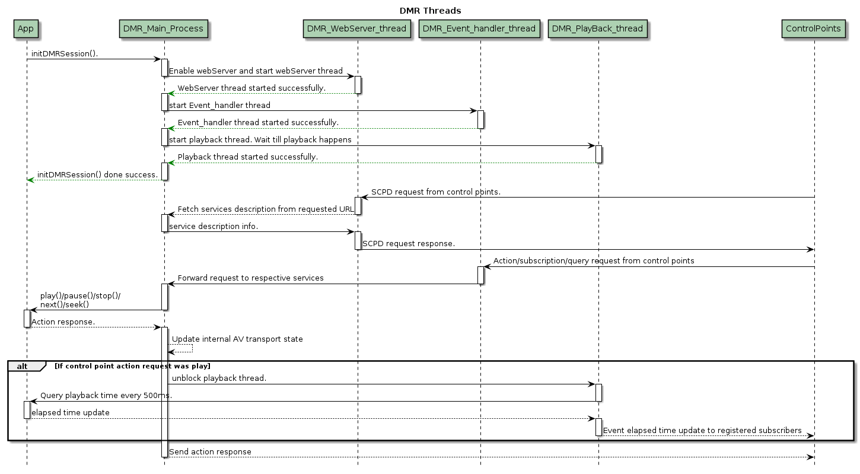

- Init-DeInit DMR Session
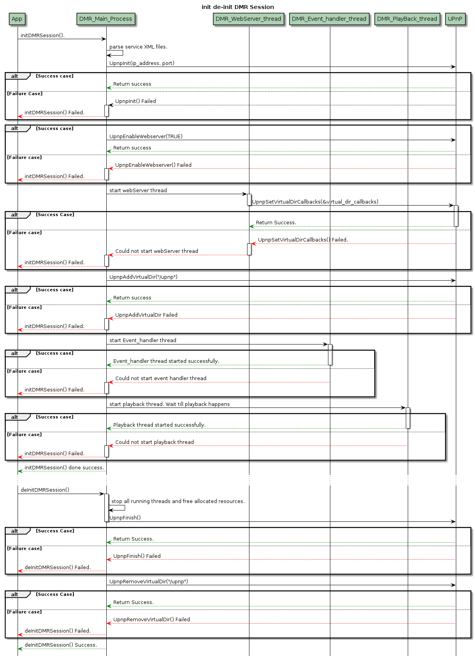
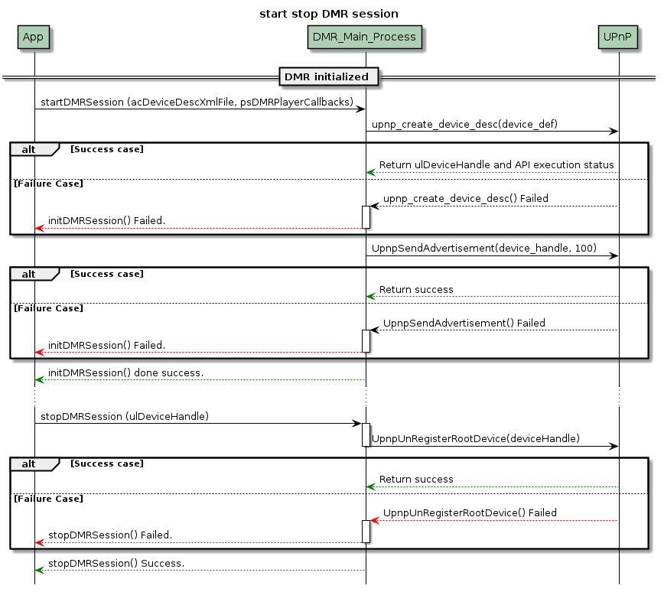
- Start stop DMR Session

- Play

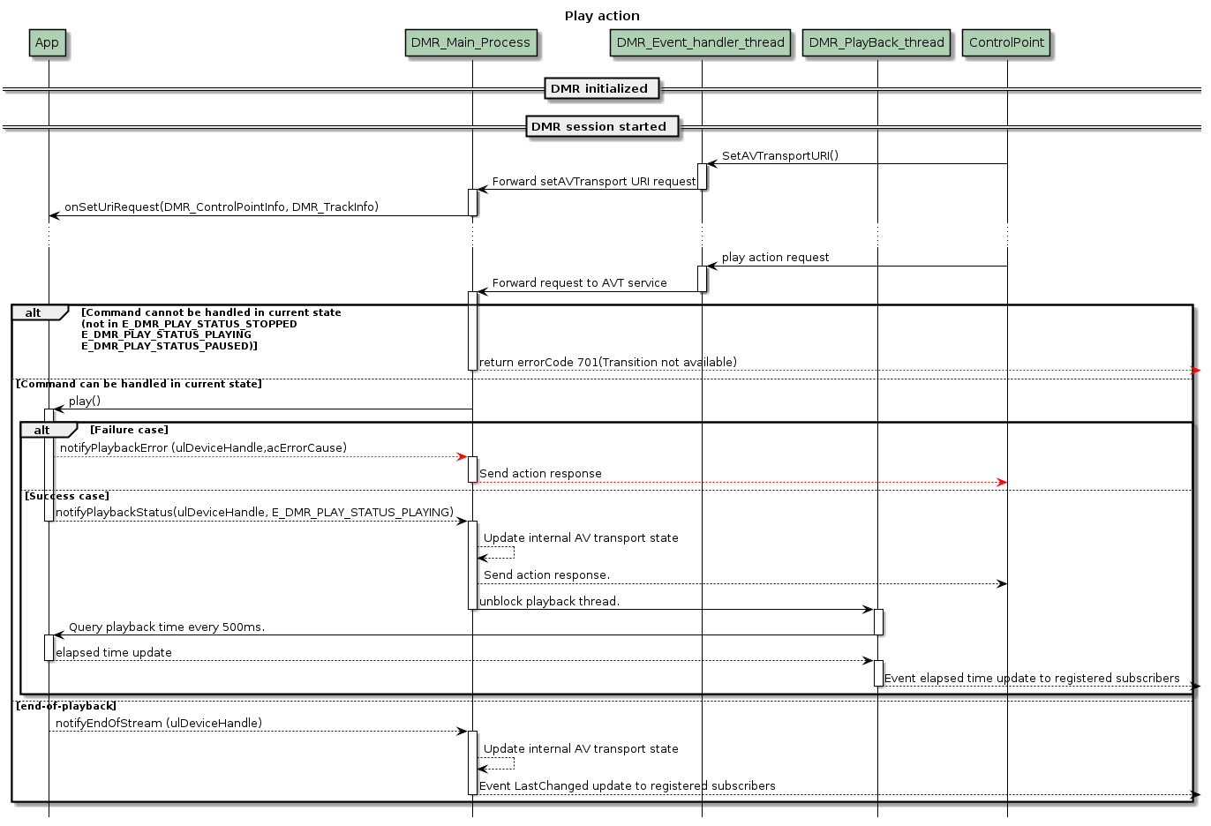

- Pause
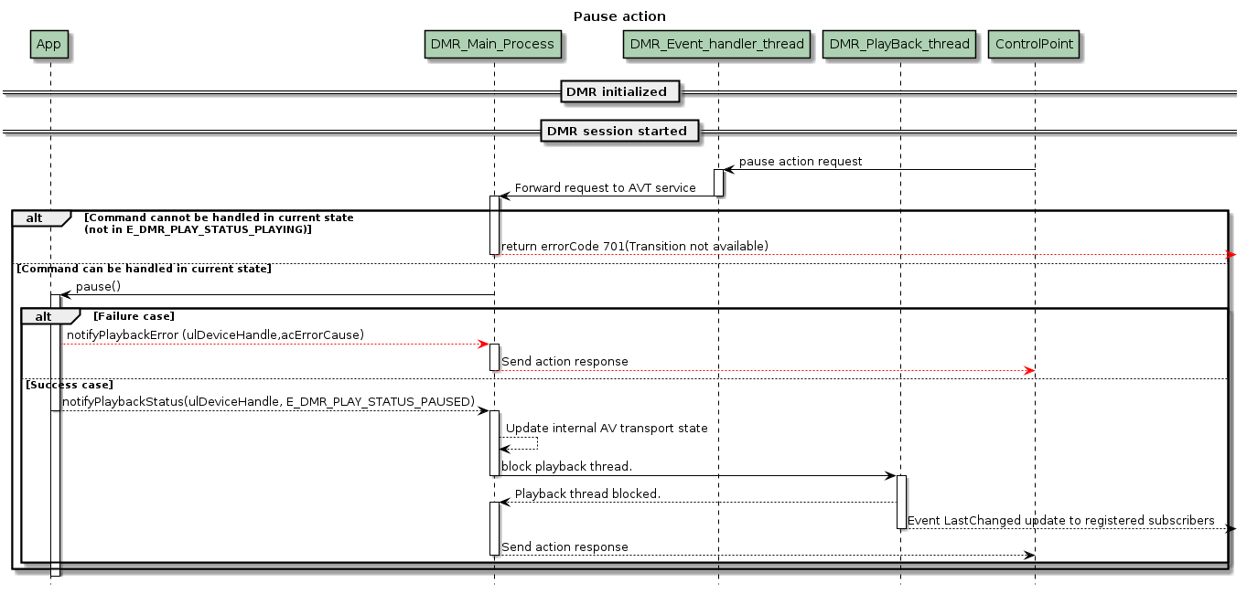

- Stop
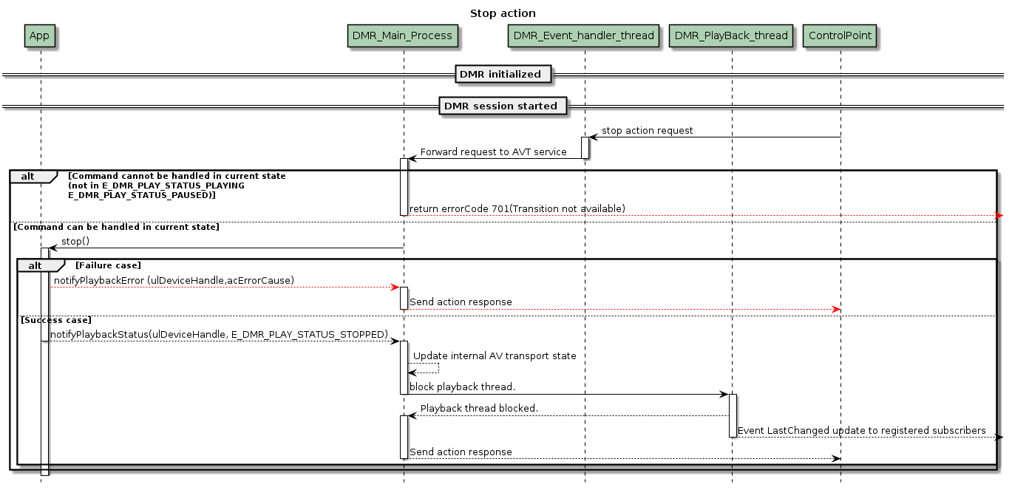

- Seek
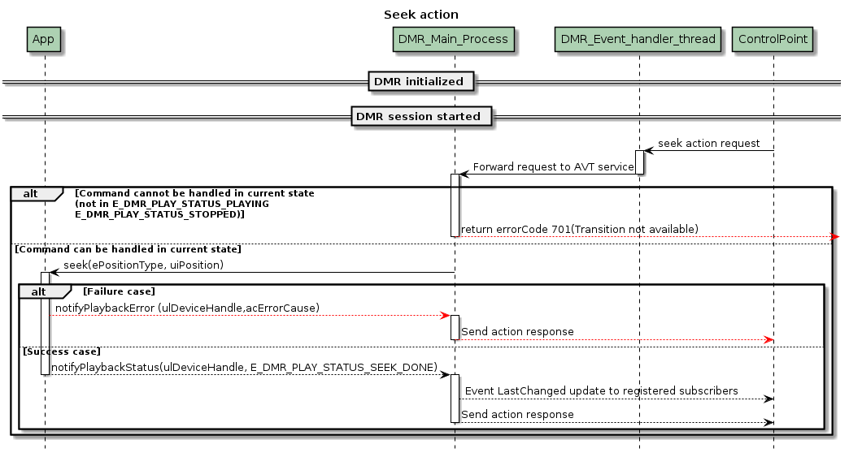

FileStructure
This sections contains file structure of DLNA DMR.

IDMRDeviceCallbacks.hpp | Interface file for Application. Defines device callbacks.
IDMRPlayerCallbacks.hpp | Interface file for Application. Defines play, pause, stop, seek etc..  callbacks to be implemented by application.
IDMRSessionIface.hpp | Interface file for Application. Defines player and session API's.
renderer_types.hpp | DMR user defined data types.

Interfaces
DLNA-API-Guide.chm

Limitation
Section contains limitation which may be imposed because of design.

Assumption
This section contains Assumptions made for the design.

Traceability

SNo | Requirement ID | Design Document Section | Status | Comments
1 | DMR_REQ_GENERAL_0001 | LLD_SEC_3
2 | DMR_REQ_GENERAL_0002 | LLD_SEC_3.1.6
3 | DMR_REQ_GENERAL_0003 | LLD_SEC_3.1.5
4 | DMR_REQ_GENERAL_0004 | LLD_SEC_3.1.4
5 | DMR_REQ_GENERAL_0005 | LLD_SEC_3
6 | DMR_REQ_GENERAL_0006 | LLD_SEC_3
7 | DMR_REQ_GENERAL_0007 | LLD_SEC_3
8 | DMR_REQ_GENERAL_0008 | LLD_SEC_3
9 | DMR_REQ_FUNC_0001
10 | DMR_REQ_FUNC_0002
11 | DMR_REQ_FUNC_0003
12 | DMR_REQ_FUNC_0004
13 | DMR_REQ_FUNC_0005
14 | DMR_REQ_FUNC_0006
15 | DMR_REQ_FUNC_0007
16 | DMR_REQ_FUNC_0008
17 | DMR_REQ_FUNC_0009
18 | DMR_REQ_FUNC_0010
19 | DMR_REQ_FUNC_0011
20 | DMR_REQ_FUNC_0012
21 | DMR_REQ_FUNC_0013
22 | DMR_REQ_FUNC_0014
23 | DMR_REQ_FUNC_0015
24 | DMR_REQ_FUNC_0016
25 | DMR_REQ_FUNC_0017
26 | DMR_REQ_FUNC_0018
27 | DMR_REQ_FUNC_0019
28 | DMR_REQ_FUNC_0020
29 | DMR_REQ_FUNC_0021
30 | DMR_REQ_FUNC_0022
31 | DMR_REQ_FUNC_0023
32 | DMR_REQ_FUNC_0024
33 | DMR_REQ_FUNC_0025
34 | DMR_REQ_INTERFACE_0001
35 | DMR_REQ_INTERFACE_0002
36 | DMR_REQ_INTERFACE_0003
37 | DMR_REQ_INTERFACE_0004
38 | DMR_REQ_INTERFACE_0005
39 | DMR_REQ_INTERFACE_0006
40 | DMR_REQ_INTERFACE_0007
41 | DMR_REQ_INTERFACE_0008
42 | DMR_REQ_INTERFACE_0009
43 | DMR_REQ_INTERFACE_0010
44 | DMR_REQ_INTERFACE_0011
45 | DMR_REQ_INTERFACE_0012
46 | DMR_REQ_INTERFACE_0013
47 | DMR_REQ_INTERFACE_0014
48 | DMR_REQ_INTERFACE_0015
49 | DMR_REQ_INTERFACE_0016
50 | DMR_REQ_INTERFACE_0017
51 | DMR_REQ_INTERFACE_0018
52 | DMR_REQ_INTERFACE_0019
53 | DMR_REQ_INTERFACE_0020
54 | DMR_REQ_INTERFACE_0021

Platform Dependencies
DLNA DMR depends on libUPnP and IP network. These dependencies must be provided by android platform for DMR to work properly. DMR library makes use stardard c++ constructs and templates for implementation.

External References
https://spirespark.com/dlna/

List of reference readings links:
www.upnp.org/specs/av/UPnP-av-AVArchitecture-v1-20020625.pdf
www.upnp.org/specs/av/UPnP-av-MediaRenderer-v1-Device.pdf
www.upnp.org/specs/arch/UPnP-arch-DeviceArchitecture-v1.0-20060720.pdf

